Name: Ningyuan Zhang

Section: A

Date: 3/1/2017

Instructor: Akhilesh Tyagi

Lab-6

1. **Multiplicand**

the code was contained in file multiplicand.vhd

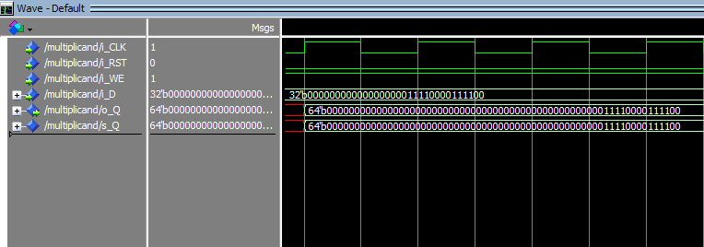

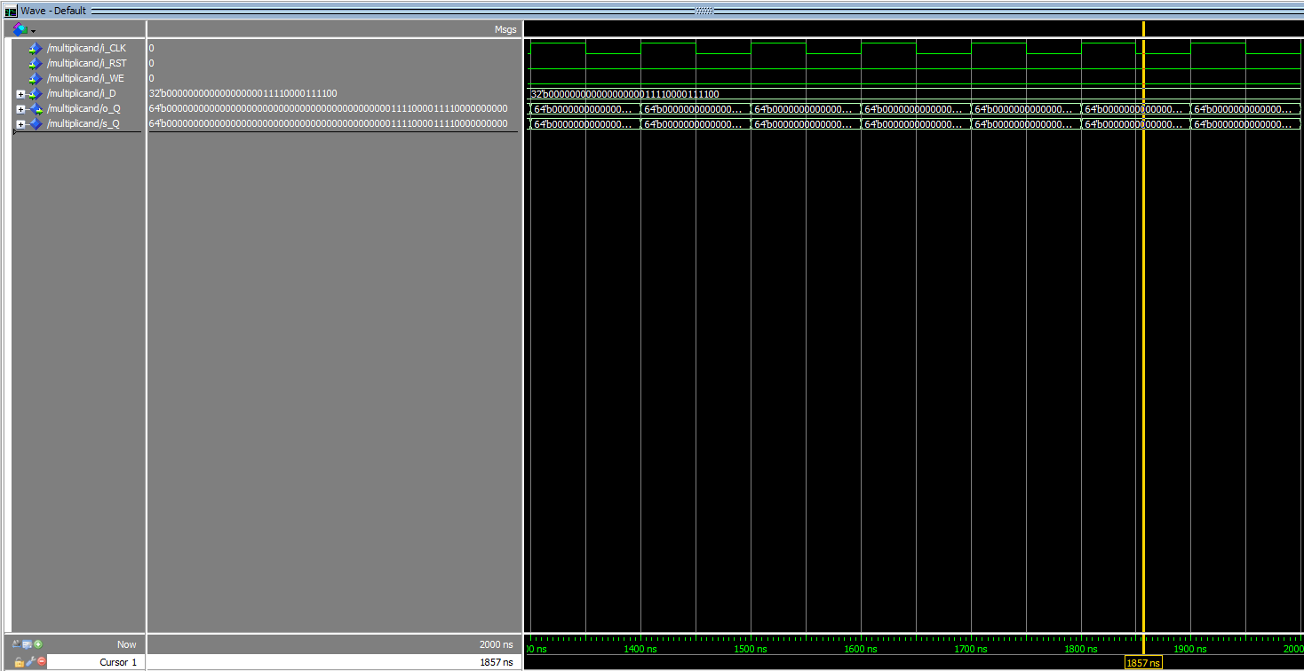

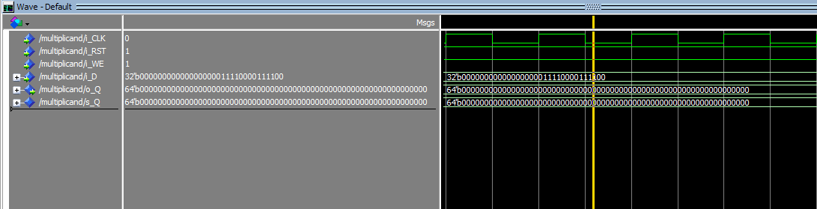

I did not use the instruction sll (shift left logiccally) in my shift motion, instead I directly added 0 into right side and popped out the most left bit.

**2. Multiplier**

the code file was multiplier.vhd

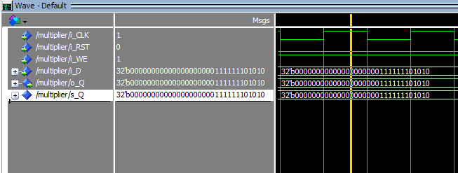

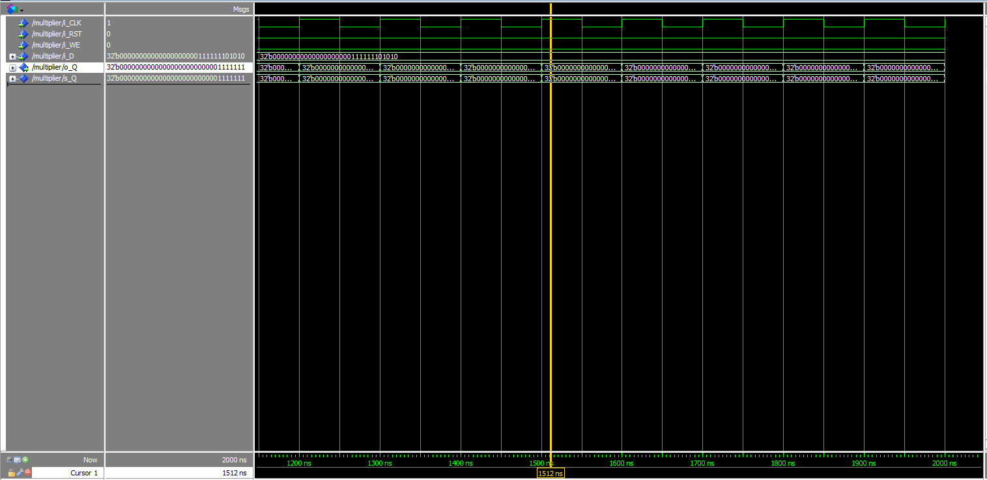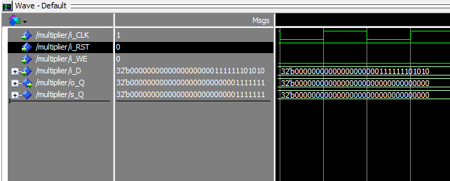

I did not use the instruction srl (shift right logiccally) in my shift motion, instead I directly added 0 into left side and popped out the most right bit.

**3. 64-bit ALU**

the code file was six_fou_bit_ALU.vhd

I use VHDL directly to write the file.

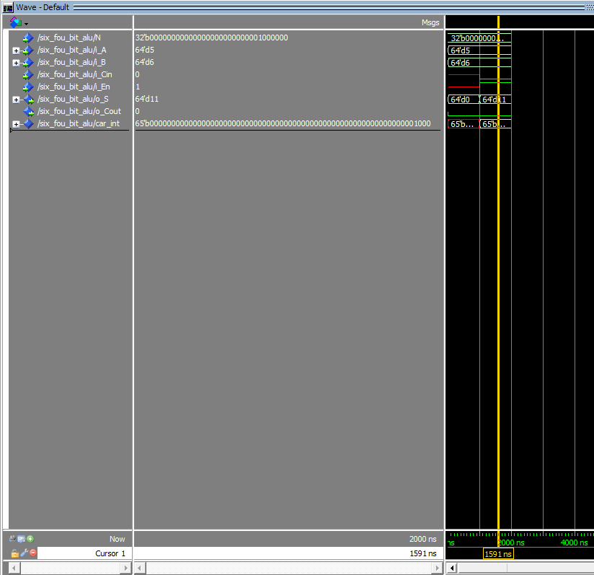

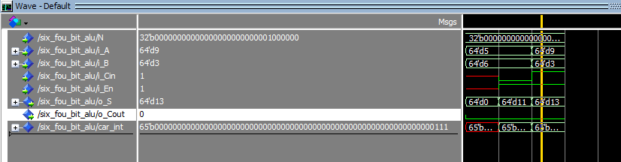

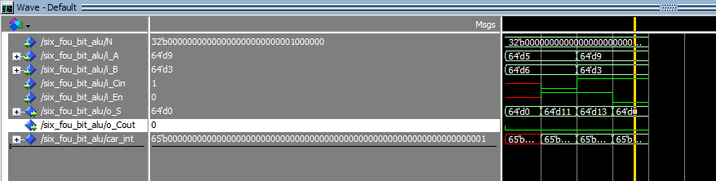

**4. Multiplication**

the 64-bit two to one mux file was six_fou_ttomux.vhd

and the 64-bit register was six_fou_single_reg.vhd

the final multiplication called lab6.vhd

